**Lab 5: Retrieving Data from the Database**

Program.cs:

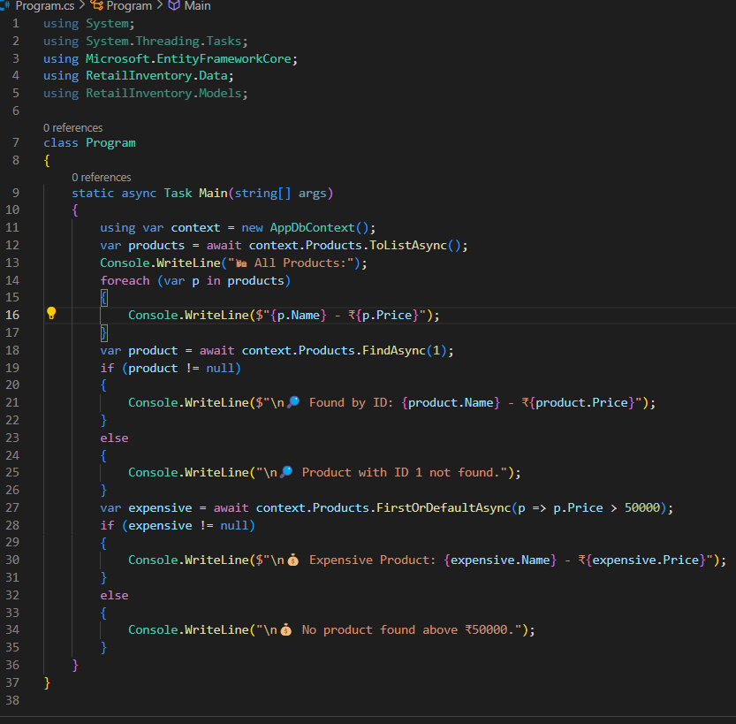

Output:

